REGISTRATION FORM
Art Markets: an integrated perspective
International Summer School – Lisbon, July 10-14, 2023

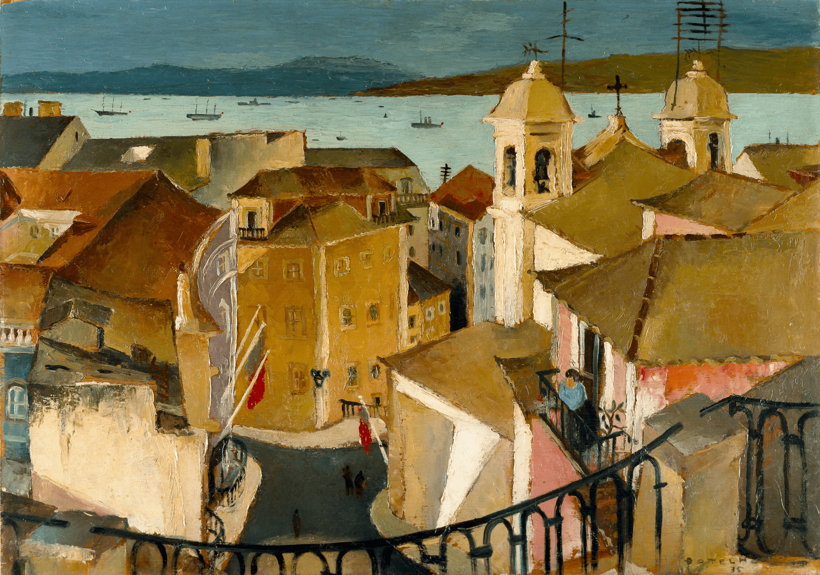
Carlos Botelho, Lisboa e o Tejo, Domingo, 1935. © MNAC, Arnaldo Soares (DGPC/ADF)

- PERSONAL DATA
NAME:
AFFILIATION:
ADDRESS:
COUNTRY:
EMAIL:

- REGISTRATION FEE (Full participation - 1000€ / Students – 850€)
The rates include the cost of the five days of training, meals, and accommodation at Hotel Golf Mar Vimeiro (July 10-14, 2023). The student rate is for a shared room; for participants wishing a single room, an additional fee will apply, payable at the hotel. All extra consumption is the responsibility of each participant.

​The workshop on provenance issues at the Museu Nacional de Arte Antiga and Playful Rules (The Ins & Outs of Auctions) at the Palácio do Correio Velho auction house, both in Lisbon, are included as well.

- RECEIPT
NAME (individual participant or institution):
ADDRESS:
TAX/VAT NUMBER:

The receipt will be issued and sent by email during the month of May, 2023.
Please note that once the receipt is issued it will not be possible to change these details.

- PAYMENT (UNTIL MAY 1, 2023)
Registration fees must be paid by bank transfer. All additional transfer fees must be paid by the participants. No refund will be possible.

PAYMENT BY BANK TRANSFER:
Registration fees must be paid to the following account:

Bank: Banco Santander Totta S.A.
Beneficiary/Account holder: FCSH – Univ. Nova de Lisboa
Address: Avenida de Berna, 26-C, 1069-061 Lisboa, Portugal
IBAN: PT50 0018 000321419114020 13
BIC/SWIFT: TOTAPTPL

Payment description (mandatory): IHA – ART MARKETS SUMMER SCHOOL 2023

- TERMS AND CONDITIONS
To complete your registration, you must send this form to the IHA Art Markets Summer School e-mail address: artmarkets.summerschool2023@gmail.com, together with the bank transfer receipt.
Your registration will be confirmed (by e-mail) after we have received these documents and payment. Please note that, in case of withdrawal or cancellation of your participation, it will not be possible to refund any registration fee previously paid.
By filling in and returning this form, you agree to have read and accepted these terms and conditions.

All data provided will be treated as confidential. Under no circumstances will the data collected be used for any purpose other than that the context of this event.

Touchpoints:
Sofia Guiomar
Adelaide Duarte

Organization (2023 ed.):
Art History Institute (FCSH, Universidade NOVA de Lisboa)
Erasmus University Rotterdam
University of Leuven (KU Leuven)
Université Libre de Bruxelles
Laboratoire de Recherche Historique Rhône-Alpes (LARHRA)

Website: https://artmarkets-summerschool.weebly.com/

